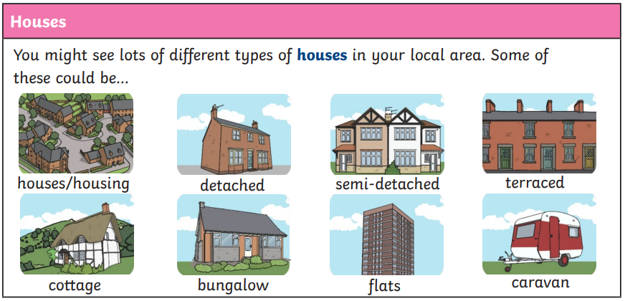
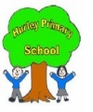
Where My wellies take me Year 1 Knowledge Organiser
Geography Features
Human | A human geographical feature is something that has been made, built or creature by Humans. This would be house, buildings, shops ect.
Physical | A physical geographical feature is something that has been made natural and in nature. This would be a forest, river, lake, beach, hill ect.
Right
Left

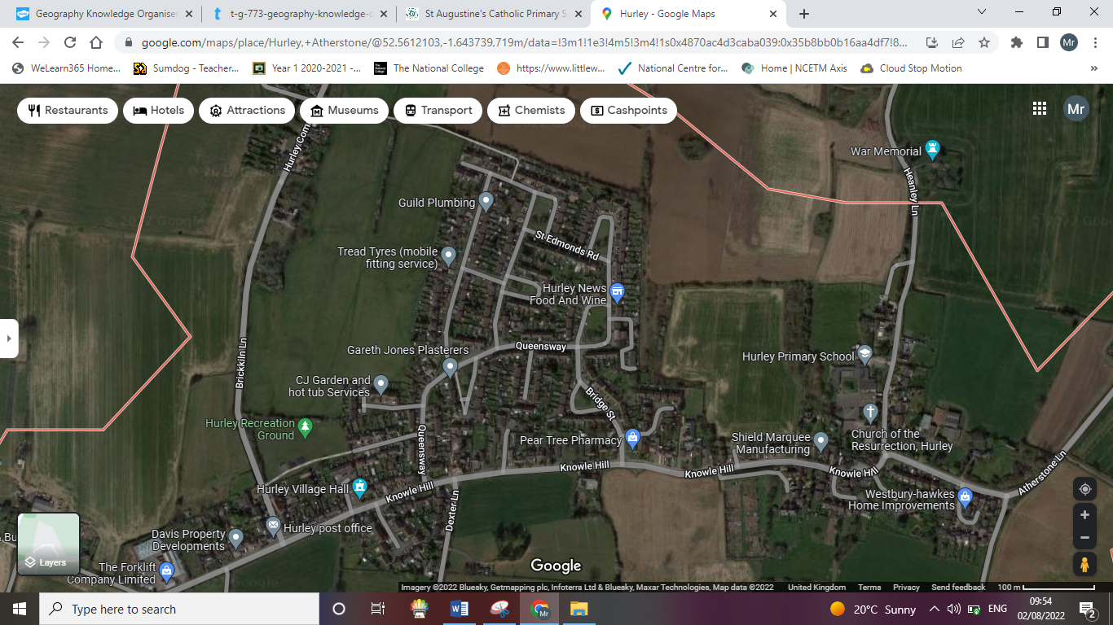
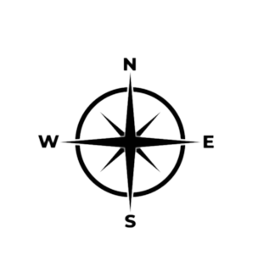
Key Vocabulary
City | A large town that usually has a cathedral.
Town | a large group of houses, shops and buildings where people live and work. Towns are larger than villages but smaller than cities.
Farm | An area of land used to produce crops or to breed animals’ and livestock.
Factory | Where goods and made in large quantities.
House | A building designed for people to live in.
Office | A building of rooms where business and work is carried out by office workers.
Port | A town or city with a harbour or access to water where ships can load and unload.
Harbour | A place on the coast where ships may moor in shelter.
Shop | A building in which goods and sold. Examples – supermarkets, clothes shops and toy shops.

