

Welcome to Year 5!

Teachers: Mrs Bradbury & Mr Davies
Teaching Assistant: Mrs Avery and Mrs Masters

Mr Davies will be teaching the start of the week (Mon & Tues) and Mrs. Bradbury will be teaching the end of the week (Thurs & Fri) alternating each Wednesday.

We hope you had a lovely summer break, refreshed and ready to start Year 5!

This newsletter will give you an overview of what to expect this term. We will be using Dojo to communicate messages and share what we’ve been doing in school.

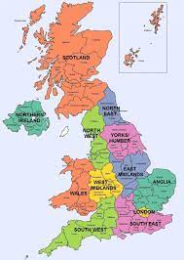
Topic: Our topic for Autumn 1 is ‘Changes’. In this unit, the children will find out about the regions of the UK, discovering how some of these areas have changed over time. The children will research how specific areas of the UK have been affected by change.

PE lessons: This half term, PE will be on a Monday afternoon with our PE coach and Thursday morning (gymnastics). Please make sure your child is wearing their full PE kit for both of these days.

Reading: We will endeavour to hear your child read individually once a week. They will also have the opportunity to read aloud to the class during Guided Reading lessons. It is vitally important that your child reads frequently at home. When they have finished their book and you have written in their home/school diary, the book needs to be placed into the ‘book change box’ to be changed. There will be rewards for children who read at home.
If you have any school books at home, please return them to school.


Homework: Homework will be handed out every Friday and needs to be returned the following Wednesday. The homework set will be based on what the children have been learning that week so should be able to have a go at it independently. If your child is struggling to complete their homework at home, please let us know and we will help them.
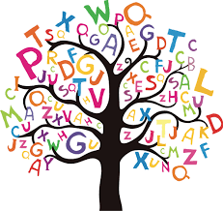
Spellings: Children will be sent home with a copy of their spellings for this half term. We will also put them on Dojo. Please help your child practise them at home.


Uniform: Please make sure your child is wearing the correct uniform and make sure it is all clearly labelled.

We’re so excited to be teaching you this year and can’t wait for all the fun we will have. We know you’re going to be amazing!

Mrs Bradbury, Mr Davies, Mrs Avery and Mrs Masters

